CHAPTER 1: INTRODUCTION TO RESEARCH
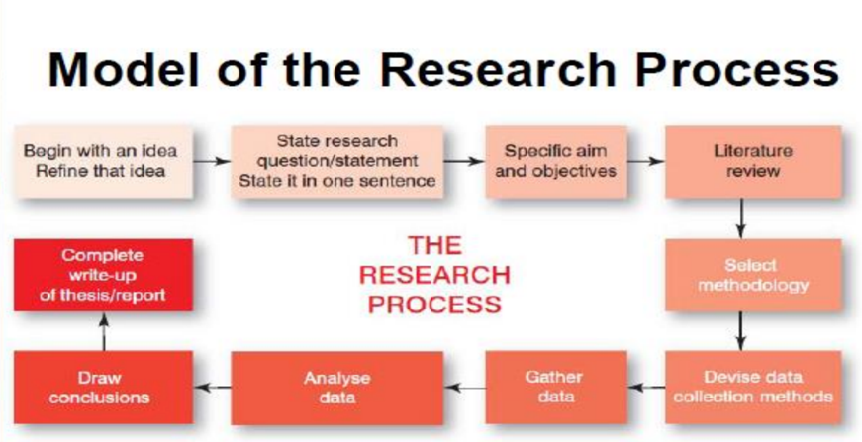

Business Research: The application of social science research methods in the process of examining business phenomena. It includes defining business opportunities and problems, generating ideas, monitoring performance and understanding the business process.

Business research continues to change, due to:
- Changes in communication technologies
- Virtually everyone is “connected”
- Trend toward an ever more “global marketplace”
- Changes in computer technology
- Easier data collection and data analysis

Business research has become increasingly global:
- Fewer geographic boundaries
- Extensive international research operations
- Conduct business in foreign countries
- Must understand the nature of those particular markets
- Judge whether they require customised business strategies

Basic (pure) research: Conducted without a specific decision in mind; does not address the needs of a specific organisation; attempts to expand the limits of knowledge in general; not aimed at solving a particular pragmatic problem
- General, simply collecting data on customers who visit your store regardless of products they buy

Applied research: Conducted to address a specific business decision for a specific firm or organisation
- Specific, collecting data on customers about a specific brand or product they buy from your store

The 4 Frameworks approach: Developed to provide students with a simple guide to help them develop their research projects
1. The conceptual framework
2. The theoretical framework
3. The methodological framework
4. The analytical framework

1. Conceptual Framework: Contained in the research statement/ question
Step 1: Begin with an idea; refine that idea
Step 2: State the research question/statement in one sentence
Step 3: Specific aim and objectives
- The research statement contains: All of the key concepts in the research project; A statement of the research methodology to be used in the research project; Stated in one sentence

2. Theoretical Framework: Contained in the literature review
Contained in the researcher's literature review:
- To assess the state of knowledge in the field
- To identify any gaps in knowledge in the field
- To develop their own expertise in the area or field of their research
Theoretical framework: Key concepts (in conceptual framework) guide researcher in their search for literature and the structure and content for literature review
- Mention ALL the key concepts
- Mention the theory on which the research was based

3. Methodological Framework: Contained in the methodology section
- How the research was conducted
- Research methodology: The way in which the research was conducted (Case study, survey, experimental design, meta analysis, attitude research, action research, ethnography, feminist research, grounded theory)
Decisions regarding research methodology are made with reference to the:
- Aim and objectives; Population; Type of data required; Most appropriate data collection method
- Data: The raw facts or things that have been recorded but which have not been processed
- Information: The result of data processing; the end result of changing data into something useful
Methodological framework: Contains all information on the way in which the research was conducted
- Mention ALL ways in which the research was conducted, including: Research methodology; Research method / data collection method

4. Analytical Framework: Contained in the data analysis presented in the thesis
The structure of the analysis of data presented in research report/thesis:
- A synopsis of the analysis carried out for the research;
- The aspects of data analysis that are to be presented in the written account
- The researcher is guided in the work of carrying out data analysis and presentation of findings by the conceptual and theoretical frameworks
Analytical framework: Formal written account of the data analysis and findings.
- Mention ALL ways which data was analysed; Discuss findings and conclusions

Problems students may encounter when approaching research methods:
- Distinguish between an area of interest, and a topic for a research project
- Need an idea for a topic within that area
- A common mistake: attempt to develop research idea into research project; Define research project too broadly (must be focused)

How to formulate a research project:
The Test of Researchability: Used to assess whether a research project could be undertaken and to examine if the resources are available
Consider:
- Time needed to conduct the research
- Money needed
- Access to data

Writing up the Research: Thesis/ Report
- Follows a pattern, sequential and organic
- Any changes effect the entire project
Thesis: Written record of research project
- A synopsis of all of the work carried out
- Word count is always constrained

